**Online Examination System (OES)**

**GROUP NO**

**22-FYP-102**

**SESSION 2018-2022**

**BACHELOR OF SCIENCE**

**IN**

**COMPUTER SCIENCE**

**SUBMITTED BY**

**M. Ahsan Shahid 18-NTU-CS-1052**

**Muhammad Umer 18-NTU-CS-1049**

**SUPERVISED BY**

Dr. Rehan Ashraf

**CO-SUPERVISED BY**

Dr. Hamid Ali

**DEPARTMENT OF COMPUTER SCIENCE, NATIONAL TEXTILE UNIVERSITY,**

**FAISALABAD-37610, PAKISTAN**

**Table of Contents**

Contents

1.1. Project Overview 2

1.2. Problem Statement 2

1.3. Purpose 2

1.4. Cost Benefit Analysis 3

1.5. Objectives 3

1.6. Scope 3

1.7. Enhancement Scope 4

1.8. Definitions, Acronyms 4

2. Literature Review 6

2.1. System Design 6

2.2. Problems with exiting solution 8

2.3. Reasons of Development 9

3. Functional or Specific Requirements 11

3.1. Methodology 11

3.2. Aspect 13

3.2.1. Administrator Aspect 13

3.2.2. Faculty Aspects 13

3.2.3. Student Aspects 14

3.2.4. Analysis 14

3.2.5. Mailing 14

3.3. External Interface Requirements 15

3.3.1. Hardware Interfaces 15

3.3.2. Software Interface 15

3.3.3. Third Party Software Interfaces 15

3.3.4. Communication Protocol 16

3.3.5. Assumption and Dependency 16

3.4. Non-Functional Requirements 16

3.5. Software System Attributes 17

3.5.1. Browser Compatibility 17

3.6. Database Requirements 18

3.7. Technologies 18

3.8. Software 18

3.9. Test Cases 18

3.9.1. Black Box Testing 18

3.9.2. White Box Testing 18

3.9.3. Test Cases 19

3.9.3.1. Test Case: Login 19

3.9.3.2. Test Case: Add Department 19

3.9.3.3. Test Case: Add Categories 19

3.9.3.4. Test Case: Add Subjects 20

3.9.3.5. Test Case: Add Students 20

3.9.3.6. Test Case: Add Faculty 20

3.9.3.7. Test Case: Add Notice 20

3.9.3.8. Test Case: Give Exam 21

3.9.3.9. Test Case: Send Invitation 21

3.9.3.10. Test Case: Make Exam 21

3.10. Hardware 22

3.10.1. Server 22

3.10.2. Client 22

4. Analysis and Design 24

4.1. Use Case Diagram 24

4.1.1. Use case Overview 24

4.1.2. Add Faculty Use Case 25

4.1.3. Login Use Case 26

4.1.4. Student Registration Use Case 27

4.1.5. User Profile Edit Use Case 28

4.1.6. Manage Test Use Case 29

4.1.7. Appear for Test Use Case 30

4.1.8. Generate Result Use Case 31

4.2. Activity Diagram 32

4.2.1. Login Activity Diagram 32

4.2.2. Manage Students Activity Diagram 33

4.2.3. Manage Tests Activity Diagram 34

4.2.4. Generate Result Activity Diagram 35

4.2.5. Student Registration Activity Diagram 36

4.2.6. Answer Test Activity Diagram 37

4.3. Sequence Diagrams 38

4.3.1. Sequence Diagram Overview 38

4.3.2. Login Sequence Diagram 39

4.3.3. Manage Test Sequence Diagram 40

4.3.4. Appear for Test Sequence Diagram 41

4.4. Class Diagram 42

4.5. Database Design 43

4.6. Tables 44

4.6.1. Table: Tbl_users 44

4.6.2. Table: Tbl_teacher 44

4.6.3. Table: Tbl_subjects 45

4.6.4. Table: Tbl_question_answer 45

4.6.5. Tbl_questions 45

4.6.6. Table: Tbl_notice 46

4.6.7. Table: Tbl_examination 46

4.6.8. Table: Tbl_departments 46

4.6.9. Table: Tbl_categories 47

4.6.10. Table: Tbl_assessment_records 47

4.6.11. Table: Tbl_assessment_practice_records 47

4.6.12. Table: Tbl_alerts 48

5. UserInterface 50

5.1. Admin Panel 50

5.1.1. Login 50

5.1.2. Admin Profile 51

5.1.3. Dashboard 51

5.1.4. Departments 52

5.1.5. Categories 53

5.1.6. Subjects 54

5.1.7. Students 55

5.1.8. Faculty 56

5.1.9. Notice 57

5.1.10. Export Database 58

5.2. Student Panel 59

5.2.1. Student Profile 59

5.2.2. Dashboard 59

5.2.3. Subjects 60

5.2.4. Students 60

5.2.5. Examination 61

5.2.6. Exam Results 63

5.3. Teacher Panel 64

5.3.1. Teacher Profile 64

5.3.2. Dashboard 64

5.3.3. Subject 65

5.3.4. Send Invitation 65

5.3.5. Candidate 66

5.3.6. Examination 67

5.3.7. Questions 68

5.3.8. Exam Result 69

6. References 71

6.1. References 71

**List of Figures**

Figure 1: Waterfall Methodology 11

Figure 2: Use Case-Overview 24

Figure 3: Use Case-Add Faculty 25

Figure 4: Use Case-Login 26

Figure 5: Use Case-Student Registration 27

Figure 6: Use Case-Profile Edit 28

Figure 7: Use Case-Manage Test 29

Figure 8: Use Case- Appear for Test 30

Figure 9: Use Case-Generate Result 31

Figure 10: Activity Diagram-Login 32

Figure 11: Activity Diagram-Manage Students Activity 33

Figure 12: Activity Diagram-Manage Test 34

Figure 13: Activity Diagram-Generate Result 35

Figure 14: Activity Diagram-Student Registration 36

Figure 15: Activity Diagram-Answer Test 37

Figure 16: Sequence Diagram-Overview 38

Figure 17: Sequence Diagram-Login 39

Figure 18: Sequence Diagram-Manage Test 40

Figure 19: Sequence Diagram-Appear for Test 41

Figure 20: Class Diagram 42

Figure 21: Database Design 43

**List of Tables**

Table 1: Definitions, Acronyms 4

Table 2: Browser Compatibility 17

Table 3: Database Table-User 44

Table 4:Database Table-Teacher 44

Table 5: Database Table-Subjects 45

Table 6: Database Table-Q&A 45

Table 7: Database Table-Questions 45

Table 8: Database Table-Notices 46

Table 9: Database Table-Examinations 46

Table 10: Database Table-Departments 46

Table 11: Database Table-Categories 47

Table 12: Database Table-Assessment Records 47

Table 13: Database Table-Practice Record 47

Table 14: Database Table-Alerts 48

**List of ScreenShots**

Screenshots 1: Admin Login 50

Screenshots 2: Admin Profile 51

Screenshots 3: Dashboard 51

Screenshots 4: Manage Department 52

Screenshots 5: Add Department 52

Screenshots 6: Manage Categories 53

Screenshots 7: Add Categories 53

Screenshots 8: Manage Subjects 54

Screenshots 9: Add Subjects 54

Screenshots 10: Manage Students 55

Screenshots 11: Add Students 55

Screenshots 12: Manage Teachers 56

Screenshots 13: Add Teachers 56

Screenshots 14: Manage Notice 57

Screenshots 15: Add Notice 57

Screenshots 16: Export Database 58

Screenshots 17: Student Profile 59

Screenshots 18: Dashboard 59

Screenshots 19: Student Subjects 60

Screenshots 20: Students with-in Class 60

Screenshots 21: Undertaking Exam 61

Screenshots 22: Initiating Exam 61

Screenshots 23: Assessment Result 62

Screenshots 24: On-Going Exam 62

Screenshots 25: Overall Result 63

Screenshots 26: Teacher Profile 64

Screenshots 27: Teacher Dashboard 64

Screenshots 28: Teaching Subjects 65

Screenshots 29: Invitation Pane 65

Screenshots 30: Overall Students 66

Screenshots 31: Add Students 66

Screenshots 32: Overall On-Going Exams 67

Screenshots 33: Exam Creation (MCQS) 68

Screenshots 34: Exam Creation (S/Q 68

Screenshots 35: Exams Status 69

Screenshots 36: Overall Student Result 69

**Abstract**

*Online Examination System* (OES) is a technology-driven website It is a way to simplify examination activities like defining exam patterns, defining exam timer, objective sections, conducting exams using the computer or mobile devices in a paperless manner. It keeps all the record of the teachers and student and their respected activities.

It's a programme that facilitates the administration, tracking, and reporting of online examinations for a single institution. For this purpose, you may use any LAN, WAN, or the Internet. The integration of real-time monitoring proved to be the system's biggest challenge. As a result, the student may finish the test in the allocated time. After the allotted time has passed, the test is over, and the students' answers are verified mechanically, resulting in instant feedback.

Admin panel keep track of all the Departments, students and teacher’s records, their activities, subjects, ongoing exams, banned students etc. The admin can also control whether the results are shown to the students or not. In short, this system provides a flexible solution to the problems whenever physical activities likewise during corona pandemic happens.

**Acknowledgements**

I lack the words to completely convey how grateful I am to the All-Powerful Allah, the Most Gracious, the Most Merciful, and the Most Benevolent, who endowed me with the skills to conduct this work effectively. It is our highest obligation to give thanks and respect to the Holy Prophet (Peace Be Upon Him), who is a never-extinguishing beacon of light for all of humanity. We both owe a debt of gratitude to our parents and other family members, whose prayers made it possible for us to get to this point. We must remember our parents on this occasion for their love, adoration, compassion, and wisdom during every phase of my life.

I would like to take this opportunity to thank my supervisor, Dr. Rehan Ashraf, an assistant professor in the department of computer science at the National Textile University in Faisalabad, for his kind guidance, academic pursuits, and boundless drive to push the students forward. I feel extremely fortunate to be able to convey my deepest and most sincere thanks to Dr. Hamid Ali, an assistant professor in the department of computer science at the National Textile University in Faisalabad, whose advice and helpful recommendations are always there for me whenever I need them. He was constantly supportive of me, and his advice was helpful to me in finishing this assignment.

Finally, we both must express our deepest thanks to our parents for their unwavering support and ongoing encouragement during my years of education as well as throughout the process of doing research for and composing this report. Without them, this feat would not have been possible. We would like to express our gratitude to everyone who helped us, directly or indirectly, to finish the project and its report.

**Chapter No**

**1**

**Introduction**

1. **Introduction**

## Project Overview

Online examinations with set objectives are used in this project to evaluate pupils. The exams would be very adaptable. With the help of this initiative, educational institutions will be able to administer exams and use automated systems to evaluate applicants' responses for accuracy.

The concept enables professors to design their own exams. It would make it possible for educational institutions to run examinations, quizzes, and feedback forms. It requests that instructors develop their own set of questions. The instructor of the question set would have access to the response's outcome. Additionally, the student would get the results through mail. For example, preparing mock exams for educational institutions and using the project as a feedback form would both be beneficial.

## Problem Statement

During the Covid-19 outbreak last year many educational institutes were conducting online classes but there was some non-efficient mode of conducting online exams thus, had to promote the students instead. Also, it involves the use of traditional ways which was difficult to manage, and a lot of workforces was required to monitor and invigilate the students and the exams which is a time-consuming task. Furthermore, the result declaration was not rapid as we've faced recently during the Intermediate-II results.

## Purpose

* The candidates' responses will be quickly and automatically verified.
* The laborious task of evaluating the applicants' responses will be lessened using online exams.
* Because it is an integrated online examination system, less paper will be used.
* may rapidly provide a variety of reports as needed.

## Cost Benefit Analysis

Both the examiner and the student administering the test pay less. Paper and ink are now half as expensive as with the old approach. Both the examiner and the pupils no longer must pay for transportation to get to the facility. Students may take tests online, saving time and money that would otherwise be spent printing exams.

## Objectives

Objectives of OES are as follows:

* To facilitate exams controlling & monitoring.
* To keep track of admin and student log.
* To conduct more students’ exams at the same time.
* To ease the checking of the exam.
* More secure, less cheating.
* It's convenient.

## Scope

This initiative would be particularly beneficial for educational institutions where it is necessary to regularly evaluate pupils. Additionally, it might be helpful for anybody who needs feedback based on replies of an objective kind.

## Enhancement Scope

**NOTE:**

1. We only implemented objective-based questions due to time and budget constraints, but we'll expand our services to include subjective-based questions in the future.
2. The present method merely offers numerous alternatives, but only one right response may be chosen. Teachers may want to provide replies with various selections and options.
3. Despite not being used in this system, the relevant database management system and web server software would have access to security logs.
4. Users who are not registered cannot respond to tests; they must be a member of a group. This is a disadvantage if the professor wants any student, even anonymous individuals, to respond to the exam.

## Definitions, Acronyms

To fully comprehend the SRS, the accompanying Table 1 discusses the meanings of all terminology, acronyms, and abbreviations used in this work.

Table 1: Definitions, Acronyms

| **Sr. No.** | **Terms/Acronyms** | **Description** |
| --- | --- | --- |
|  | The students | The typical user is a student preparing for a test. |
|  | The Faculty Members | A second user (often a professor, lecturer, or examiner) submits a series of questions, answers, and grades. |
|  | The Administrators | Power user who can add teachers and administer the system. |

**Chapter No**

**2**

**Literature Review**

# Literature Review

Several studies and ongoing efforts aim to improve test administration and online education. Different parts of the system were the subject of some of the studies.

## 2.1. System Design

The flexibility of the system is reduced if the user interface of the system requires a lot of human effort to understand and complete all tasks.

A comparable system was created by Hou [1] and coded in the C#-based ASP.net language. Basing a system's design on C# leads to a poor user interface and limited development options, which is not feasible soon. The x-platform GUI is even worse than average. Since C# is essential to the.NET framework, the application must be hosted on a Windows-based server. The language's flexibility is decreased by the dependency on the. Net framework.

The web application only makes use of components made by Microsoft. The ASP.NET web server acts as the application's front end, C# acts as the application's intermediate language, ADO.NET makes it possible to communicate with Microsoft SQL Server, and the Microsoft database itself is what makes this feasible. Ruth Akinsanmi here [2].

It is challenging to manage several tasks using a comparable system by Bobde and Chaudhari's [3] due to issues with user privacy and a cumbersome UI. An online test may quickly measure the proficiency of students and offer some statistical assessments using a large database with a bank of questions.

As, Huszti and Petho [4]

The created programme comes with the following capabilities::

1. To increase the number of questions in the bank, instructors may add any more ones.
2. Each student may take a different Page test with questions chosen at random from a question pool.
3. It is possible to acquire various reports for the teachers, students, courses, etc.
4. Without any issues, many students may take their tests concurrently both within and outside of their institution. The client-server architecture serves as the foundation for the suggested software's functionality. One challenging aspect of e-learning security is the electronic test.

The use of a web-based examination system is an effective approach for assessing education on a large scale. Another He [5] demonstrates a web-based educational evaluation system that use Bloom's taxonomy to examine in real time how teachers teach and how students learn. Positive results from evaluating the system in science and mathematics classrooms at two nearby high schools have been obtained. As a means of decreasing anomalies, the organization responsible for administering entrance tests to all Nigerian universities, the Joint Admissions Matriculation Board (JAMB), has proposed the idea of an e-Test in Nigeria, where all applicants would be forced to complete an online entrance exam. This strategy was designed and evaluated at Covenant University, a private university in Nigeria. Research suggests the approach may address problems associated with traditional testing techniques, such as impersonation and other forms of testing fraud. Ayo Akinyemi [6].

When looking at how open university education has developed in Nigeria A discussion of the components of an effective online classroom may be found in Ipaye [7]. Another article aims to tackle this problem head-on by developing a web tool that would allow students to take and get immediate feedback on multiple-choice tests through the internet.

The method gives tests to the students and grades them mechanically. Tests may be given, replies collected, and grades given more quickly and accurately all thanks to technological advancements. It's useful for many kinds of research. Because it was accessed online, it may pass muster for either close-up or far-off scrutiny. Students taking the tests and teachers, professors, and anyone who wish to create or modify exams might all benefit from using the system. The system was built using several open-source tools, such as AJAX, PHP, HTML, and a MySQL database. To accommodate several types of exams and questions, a universal auto-grading module was developed. Assessment of the system was performed by the Quality Assurance Center at Mansoura University. The project demonstrated the usefulness of using web-based tools for evaluating students at large universities. Rashad Kandil [8].

Moodle is a popular, open-source platform for online instruction and evaluation.

[9] Moodle is a free, customizable, online learning management system. With its broad, flexible, and secure learning management facilities, it may be utilized to create a private website for interactive online classes. A learning management system (LMS) or virtual learning environment (VLE), Moodle is an initialism for "modular object-oriented dynamic learning environment." E-learning projects in government, business, and education may all make use of this system.

## 2.2. Problems with exiting solution

We examined a variety of institutions and found that manual input was used to maintain the data on students who were enrolled at the time. Additionally, every student finds it difficult to get to the testing location on exam day. An online examination method eliminates the need for manually preparing the registration application form, the question paper, and printing many copies. Calculating the total number of students enrolled and checking their data manually would take a lot of time and effort. Since so many individuals need to be hired to do this activity, time and money are being squandered.

Another aspect to take into consideration is the possibility of making mistakes. A test's creation takes longer than anticipated. It's time to manually add up the right and wrong answers. the human capacity for error. There is a limit on the number of students who may submit their papers at once. Request that the instructor keep an eye on the testing space.

The existing system lacks in various aspects which are discussed as follows:

* Poor Graphical User Interface(GUI)
* User Confidentiality
* Transparency
* User Integrity
* No updating facilities of Student, Teacher profile
* Limited Registration seats for students

## 2.3. Reasons of Development

The reason of development for our project are due to many aspects which are discussed as follows:

* To make user-friendly Graphical User Interface(GUI)
* To provide User Confidentiality
* Providing Transparency to users
* Providing User Integrity
* Providing updating facilities of Student, Teacher profile
* Un-Limited Registration seats for students
* Rapid result generation
* Result report generation
* Manageable Hierarchy
* Profile Setup Facilities

**Chapter No**

**3**

**Functional**

**&**

**Specific Requirements**

# 3. Functional or Specific Requirements

Software is necessary for conducting online "objective" style exams and giving quick results. The system must meet the following criteria:

## Methodology

**Iterative Waterfall-Model**

Figure 1: Waterfall Methodology

This Figure 1 illustrates how the Waterfall methodology works in providing the solution of the problem

The Waterfall Model was the first Process Model described. It is often referred to as a linear-sequential life cycle model. It's simple to understand and put to good use. In a waterfall paradigm, one stage cannot begin until the previous one is complete.

the following steps are included in the waterfall model:

A requirement specification document is created once all the needs of the future system have been identified and analyzed.

In this stage, known as "system design," the necessary requirements established in the previous stage are analyzed, and a system design is developed. The entire system architecture and the necessary hardware may then be established with the help of this system design.

The system is built through stages, or units, of code that are later merged based on the specifications laid forth in the system design. Testing at the unit level involves creating and verifying the functioning of individual units.

Of the individual components developed and evaluated during the implementation phase, the whole system is brought together for integration and testing. After the system has been integrated, it is evaluated thoroughly to look for problems.

Setting up the apparatus: Following successful completion of both functional and non-functional testing, the product is released to the public or deployed to the customer's environment.

Upkeep: Issues in the customer environment do develop on occasion. Certain issues are fixed with the release of patches. Further, many upgraded variants of the product have been released. The consumer's environment is altered by the application of maintenance.

Since each phase builds upon the previous ones, the development flows gradually downhill (like a waterfall). The "Waterfall Model" derives its moniker from the fact that progress to the next step is delayed until the results of the prior phase have been verified and accepted. According to this theory, a phase transition does not occur.

## Aspect

### Administrator Aspect

* Database backup procedure
* Modifying, erasing, and adding records to the database
* Including or removing teachers
* To modify the expert password, go here.

### Faculty Aspects

* + - Participating in the system by logging in.
    - Invitations sent via mail to select students
    - applicants' registrations being accepted
    - Group potential candidates in whatever way you choose, then edit or delete them
    - Making a quiz
    - In the above quiz, please post your questions in the comments section.
    - Add numerous answers to each question.
    - Selecting the best response from the alternatives provided.
    - Providing a space for free-form user response
    - If there is a time restriction on the exam, please specify it.
    - Should the questions be shuffled or not
    - Should the presented choices be shuffled or not
    - That correct answers be shown instantly when a candidate picks an option during practice tests.
    - Grade incorrect answers negatively.

### Student Aspects

* + Registration is required.
  + Entering the system
  + Modifying a user's profile
  + Choosing the exam.
  + Choose whether to take the exam in practice mode, where the right response is shown as soon as the applicant makes a choice.
  + Displaying up for the test.
  + Printing the test's results when it is finished.
  + Examining the provided replies.
  + Altering the password
  + Password reset for forgotten accounts

### Analysis

* + Using usernames and passwords to authenticate users
  + Keeping track of user activities throughout a session Recording candidates' answers to each question
  + Determining if the answer provided is accurate or not
  + Preserving a record of each user's test results

### Mailing

* + Reports must be sent to the candidates at their official address.
  + If the user has forgotten their password, a new one will be sent to them in the mail.
  + The release of the new exam will be announced through invitation.

## External Interface Requirements



### Hardware Interfaces

**Server-side hardware**

* + - * All necessary software has hardware requirements.
      * To meet the needs of the market, communication hardware has been developed.

**Client-side hardware**

* + - * Communication devices to interact with the server Software.
      * Operating systems suggested for clients

### Software Interface

**Server-side software**

* + - * Apache Tomcat web server software
      * Server-side scripting languages: PHP
      * Application software for Sedna databases MySQL
      * Windows is an acceptable OS.

**Client-side software**

* + - * Viewing in a browser that supports JavaScript, as detailed in Browser Compatibility 2.3.1

### Third Party Software Interfaces

MS Visio 2016

### Communication Protocol

Following protocols are required to be permitted on the server side

* + - HTTP incoming request
    - HTTPS incoming request if secure gateway is implemented

Following protocols are required to be permitted on the client side

* + - HTTP outgoing request
    - HTTPS outgoing request if secure gateway is implemented

### Assumption and Dependency

* Usernames are valid email addresses of respective user
* Administrator has the authority to add/delete faculty level accounts.
* Faculty have the authority to approve/expel student
* Faculty have the authority to change student’s group

## Non-Functional Requirements

* System should be able handle multiple users
* Database updating should follow transaction processing to avoid data inconsistency.

## Software System Attributes

### Browser Compatibility

Since it was web-based, the project required support for at least the most widely used browsers. The most widely used computer operating systems today are Windows XP and subsequent versions of Microsoft Windows, Linux, and Mac OS X, while the most widely used web browsers are Internet Explorer, Mozilla Firefox, Opera, Safari, and Google Chrome. The compatibility of our system with popular browsers is summarized in Table 2.

Table 2: Browser Compatibility

## Database Requirements

To effectively manage characters that are not in the English alphabet, the database fields for questions and the choices they correspond to need to be in the Unicode format.

## Technologies

In this section, all the technologies that make up the web-based system are listed.

* PHP is a popular server-side programming language due to its robust XML and MySQL compatibility.
* XML is used as the database format since it has the potential to create custom fields in case the quiz developer must add more than anticipated response alternatives and the database's performance requirements are low. Apache, as a web server, is very compatible with many different systems.

## Software

* For PHP and XML development, try either NetBeans or Eclipse.
* Utilizing Apache Tomcat as a Web Server

## Test Cases

### Black Box Testing

Black box testing is a method of evaluating a system in which the tester has no prior technical knowledge of the system. A tester operates the system by providing input and observing the expected results. This allows us to see how the system reacts to both typical and unusual user input.



### White Box Testing

A form of system testing known as "black box testing" involves the tester without having any previous technical knowledge of the system. A tester controls the system by entering data and monitoring the anticipated outcomes. By doing this, we may see how the system responds to both common and unique user input.

### Test Cases

Create test cases to evaluate the overall system performance. To verify that the system is functioning as expected, test cases are produced for each component of the system and the outcomes expected from that component.

### Test Case: Login

|  |  |  |  |  |
| --- | --- | --- | --- | --- |
| Test Case ID | Test Case Condition | Expected Result | Actual Result | Test Case Result |
| Login 5.1.1,  Login 5.2.1,  Login 5.3.1 | Fill out the Form | Login Successful | Login Successful | **PASS** |

* + - 1. Test Case: Add Department

|  |  |  |  |  |
| --- | --- | --- | --- | --- |
| Test Case ID | Test Case Condition | Expected Result | Actual Result | Test Case Result |
| Department 5.1.4 | Fill out the Form | Addition Successful | Addition Successful | **PASS** |

### Test Case: Add Categories

|  |  |  |  |  |
| --- | --- | --- | --- | --- |
| Test Case ID | Test Case Condition | Expected Result | Actual Result | Test Case Result |
| Categories 5.1.5 | Fill out the Form | Addition Successful | Addition Successful | **PASS** |

### **Test Case: Add Subjects**

|  |  |  |  |  |
| --- | --- | --- | --- | --- |
| Test Case ID | Test Case Condition | Expected Result | Actual Result | Test Case Result |
| Subjects 5.1.6 | Fill out the Form | Addition Successful | Addition Successful | **PASS** |

### Test Case: Add Students

|  |  |  |  |  |
| --- | --- | --- | --- | --- |
| Test Case ID | Test Case Condition | Expected Result | Actual Result | Test Case Result |
| Students 5.1.7 | Add Credentials | Addition Successful | Addition Successful | **PASS** |

### Test Case: Add Faculty

|  |  |  |  |  |
| --- | --- | --- | --- | --- |
| Test Case ID | Test Case Condition | Expected Result | Actual Result | Test Case Result |
| Faculty 5.1.8 | Add Credentials | Addition Successful | Addition Successful | **PASS** |

### Test Case: Add Notice

|  |  |  |  |  |
| --- | --- | --- | --- | --- |
| Test Case ID | Test Case Condition | Expected Result | Actual Result | Test Case Result |
| Notice 5.1.9 | Enter Notice | Addition Successful | Addition Successful | **PASS** |

### Test Case: Give Exam

|  |  |  |  |  |
| --- | --- | --- | --- | --- |
| Test Case ID | Test Case Condition | Expected Result | Actual Result | Test Case Result |
| Examination 5.2.5 | Select Exam | Active-Exam Successful | Active-Exam Successful | **PASS** |

### Test Case: Send Invitation

|  |  |  |  |  |
| --- | --- | --- | --- | --- |
| Test Case ID | Test Case Condition | Expected Result | Actual Result | Test Case Result |
| Send Invitation  5.3.4 | Write Invitation | Send-Invite Successful | Send-Invite Successful | **PASS** |

### Test Case: Make Exam

|  |  |  |  |  |
| --- | --- | --- | --- | --- |
| Test Case ID | Test Case Condition | Expected Result | Actual Result | Test Case Result |
| Make Exam 5.3.7 | Add Fill in the blanks/ MCQS | Exam-Creation Successful | Exam-Creation Successful | **PASS** |

## Hardware

The recommended hardware specified by the respective software would suffice the needs. The memory and processing power needed would increase as the number of users increase. The estimated hardware requirements are as specified.



### Server

The minimum hardware as recommended by all the software required on server side say web server, operating system, and development software

* Processing speed of 1.6 GHz
* 1 GB of RAM
* Network interface

### Client

The minimum hardware as recommended by all the software required on client side say web browser, operating system

* Minimum hardware depending on the operating system used
* True color visual display unit
* User peripherals for better interaction

**Chapter No**

**4**

**Analysis**

**&**

**Design Pattern**

# Analysis and Design

## Use Case Diagram

### Use case Overview

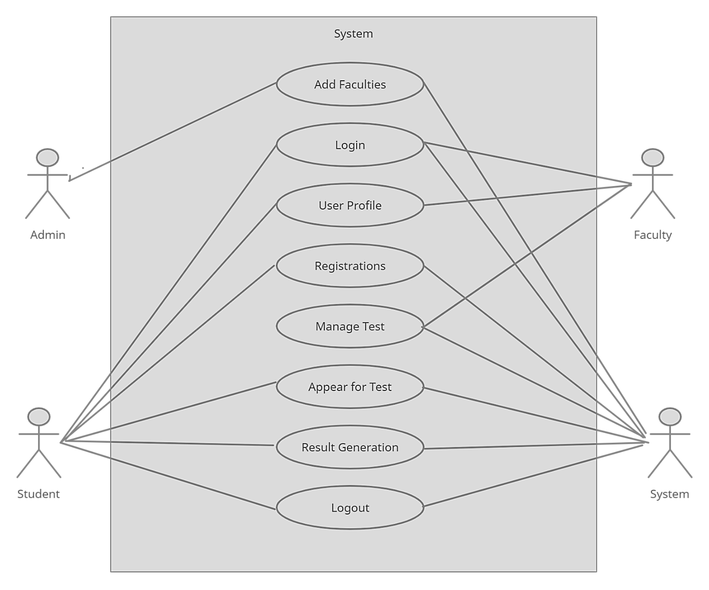The Figure 2 illustrates how the overall system collaborate with each other for its functioning.

Figure 2: Use Case-Overview

### Add Faculty Use Case

The Figure 3 illustrates Faculty login names can be added by the administrator, as well as temporary passwords for the user to sign in.

Login

Figure 3: Use Case-Add Faculty

### Login Use Case

The Figure 4 illustrates for login, students and faculty enter their username and password. Before logging in, the system verifies the username and password.

Figure 4: Use Case-Login

### Student Registration Use Case

The Figure 5 illustrates Students receive the invitation and then enter the name and password

Figure 5: Use Case-Student Registration

### User Profile Edit Use Case

The Figure 6 illustrates the admin can update the profile picture and password Students can change their profile pictures and passwords The profile picture and password can be changed by faculty

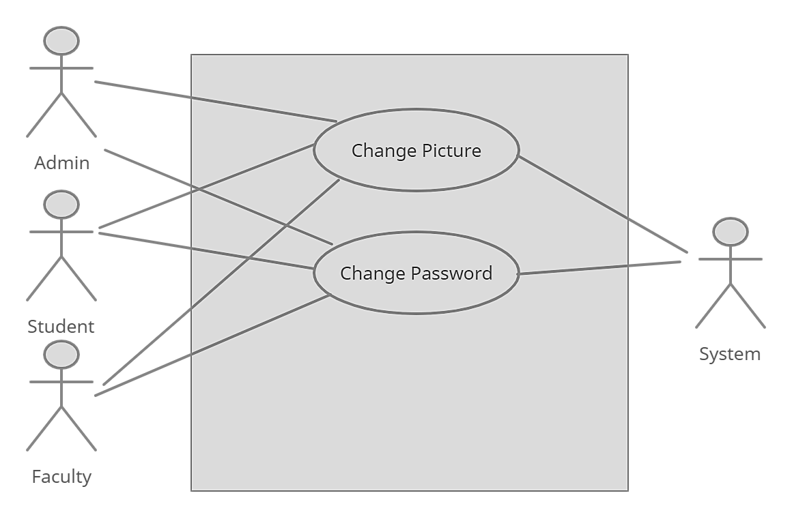

Figure 6: Use Case-Profile Edit

### Manage Test Use Case

The Figure 7 illustrates the faculty member can login, set the test title, set the exam time and date, enter the questions, and choose the correct answer out of 4 options. Overall functionality is controlled by the system

Figure 7: Use Case-Manage Test

### Appear for Test Use Case

The Figure 8 illustrates After logging in, the student chooses the test, selects the mode, and answers the questions. The system inspects the exam

Figure 8: Use Case- Appear for Test

### Generate Result Use Case

The Figure 9 illustrates the system checks the answer and calculates the marks. The result is displayed as a percentage.

Figure 9: Use Case-Generate Result

## Activity Diagram

### Login Activity Diagram

The Figure 10 illustrates the flow of login of a specific user.

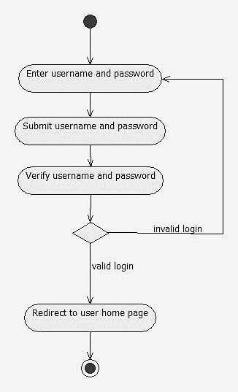



Figure 10: Activity Diagram-Login

### Manage Students Activity Diagram

The Figure 11 illustrates how the students are managed and added by their appropriate invite.



Figure 11: Activity Diagram-Manage Students Activity

### Manage Tests Activity Diagram

The Figure 12 illustrates the managing and creation of test after logging in.



Figure 12: Activity Diagram-Manage Test

### Generate Result Activity Diagram

The Figure 13 illustrates the generation of results after the exam is conducted and submitted.

Figure 13: Activity Diagram-Generate Result

### Student Registration Activity Diagram

The Figure 14 illustrates how the students on receiving an invitation e-mail gets registered for the exam.

\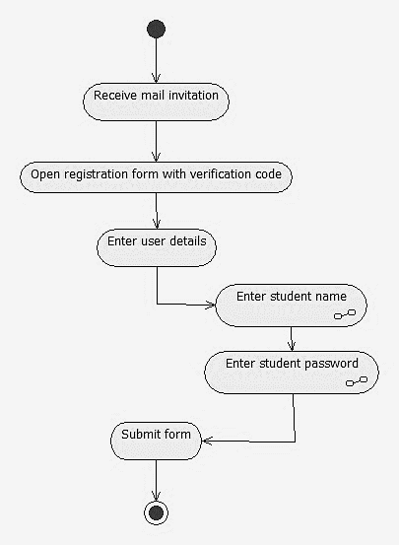

Figure 14: Activity Diagram-Student Registration

### Answer Test Activity Diagram

The Figure 15 illustrates the attempting and answering of the given question with-in the exam.

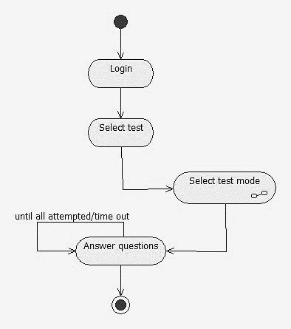

Figure 15: Activity Diagram-Answer Test

## Sequence Diagrams

### Sequence Diagram Overview

The Figure 16 illustrates the life span of different entities regarding their work with-in the preferred domain.

Figure 16: Sequence Diagram-Overview

### Login Sequence Diagram

The Figure 17 illustrates how the user log in with the system and it verifies the suer credentials with the database for the session to start.

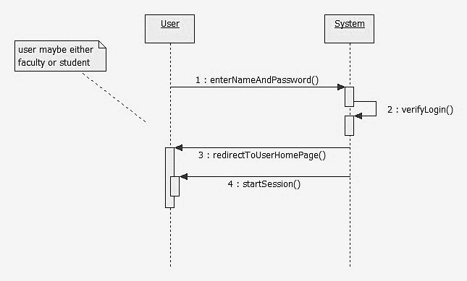

Figure 17: Sequence Diagram-Login

### Manage Test Sequence Diagram

The Figure 18 illustrates how the faculty within its lifespan creates test and then modifies it.

Figure 18: Sequence Diagram-Manage Test

### Appear for Test Sequence Diagram

The Figure 19 illustrates the student selecting its test and then selecting on which mode he/she wants to give the exam.

Figure 19: Sequence Diagram-Appear for Test

## Class Diagram

The Figure 20 illustrates all the entities and their involved relationship within the domain and how the perform different operations to get their job done.

Figure 20: Class Diagram

## Database Design

The Figure 21 illustrates the design of database and how the primary keys and foreign keys are interacting with one another.

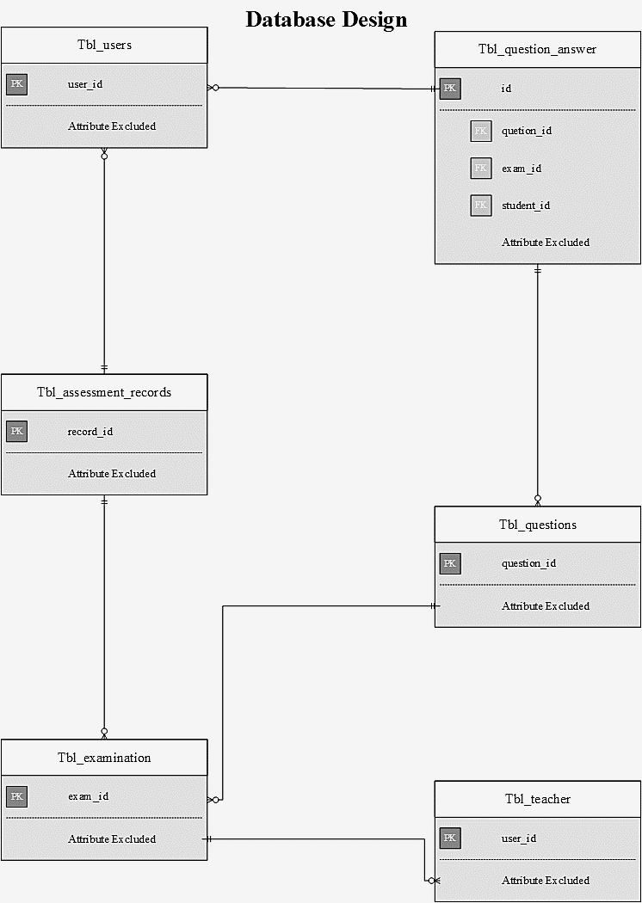

Figure 21: Database Design

## Tables

### Table: Tbl_users

The Table 3 illustrates the credentials of user within database of the system.

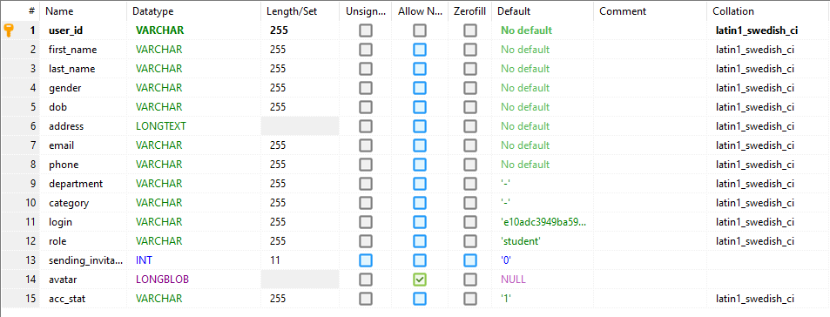

Table 3: Database Table-User

### Table: Tbl_teacher

The Table 4 illustrates the credentials of teacher within database of the system.

Table 4:Database Table-Teacher

### Table: Tbl_subjects

The Table 5 illustrates the various subjects being taught by the teachers within database of the system.

Table 5: Database Table-Subjects

### Table: Tbl_question_answer

The Table 6 illustrates the fields of the questions and answers in the database.

Table 6: Database Table-Q&A

### Tbl_questions

The Table 7 illustrates the fields and choice of options for MCQS.

Table 7: Database Table-Questions

### Table: Tbl_notice

The Table 8 illustrates the notice fields within database of the system.

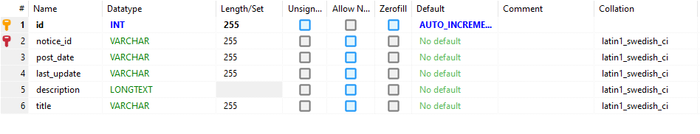

Table 8: Database Table-Notices

### Table: Tbl_examination

The Table 9 illustrates the examination fields within database of the system.

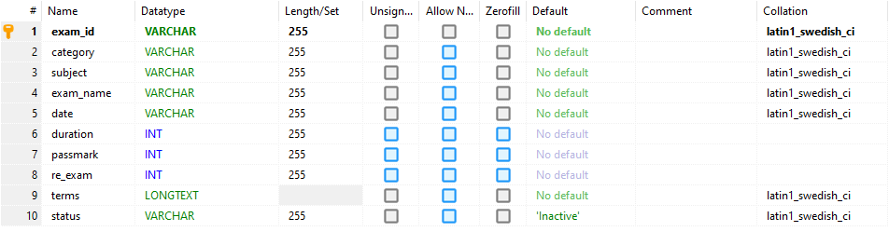

Table 9: Database Table-Examinations

### Table: Tbl_departments

The Table 10 illustrates the registered departments fields within database of the system.

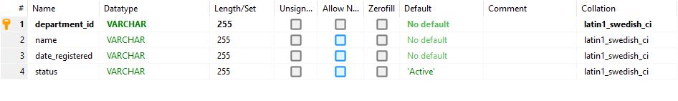

Table 10: Database Table-Departments

### 

### Table: Tbl_categories

The Table 11 illustrates the categories of the department fields within database of the system.

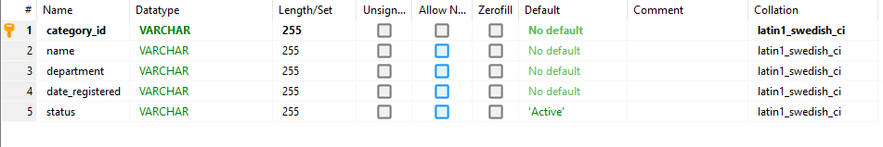

Table 11: Database Table-Categories

### Table: Tbl_assessment_records

The Table 12 illustrates the assessment record fields within database of the system.

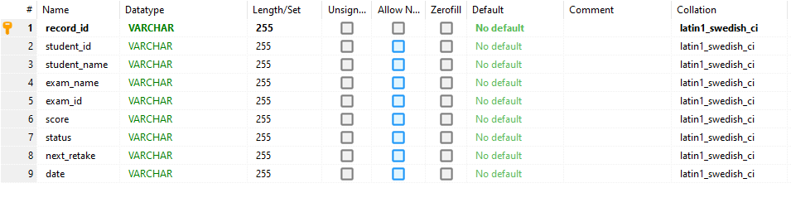

Table 12: Database Table-Assessment Records

### Table: Tbl_assessment_practice_records

The Table 13 illustrates the assessment practice record fields within database of the system.

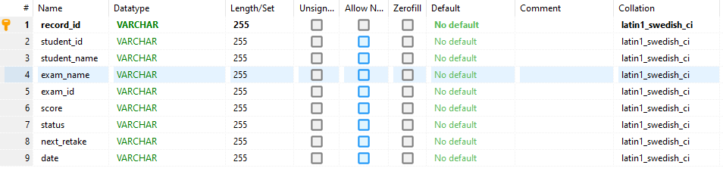

Table 13: Database Table-Practice Record

### Table: Tbl_alerts

The Table 14 illustrates the alert fields within database of the system.

Table 14: Database Table-Alerts

**Chapter No**

**5**

**User- Interface**

# UserInterface

## Admin Panel



### Login

The Screenshot 1 illustrates the admin login for it to use and view all the operations of the system.

Screenshots 1: Admin Login



### Admin Profile

The Screenshot 2 illustrates the details of the admin profile.

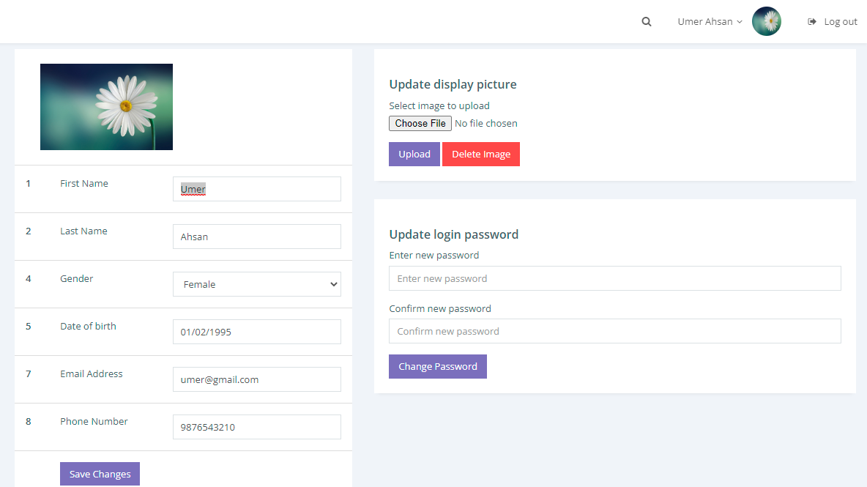

Screenshots 2: Admin Profile

### Dashboard

The Screenshot 3 illustrates the operations that can be managed by the admin.

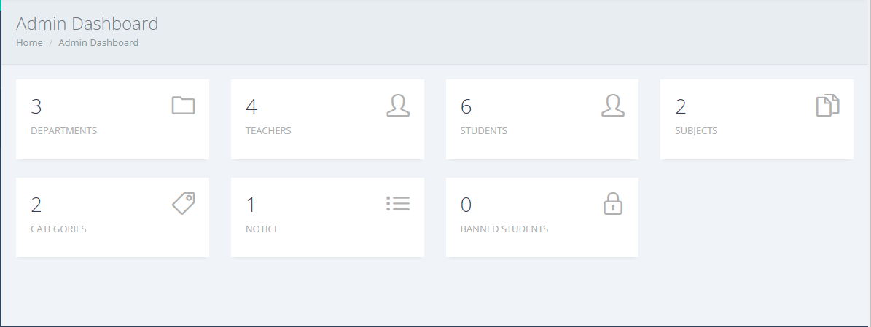

Screenshots 3: Dashboard

### Departments

The Screenshot 4 illustrates the Departments section of the dashboard which contains the status of department whether it is active or not.

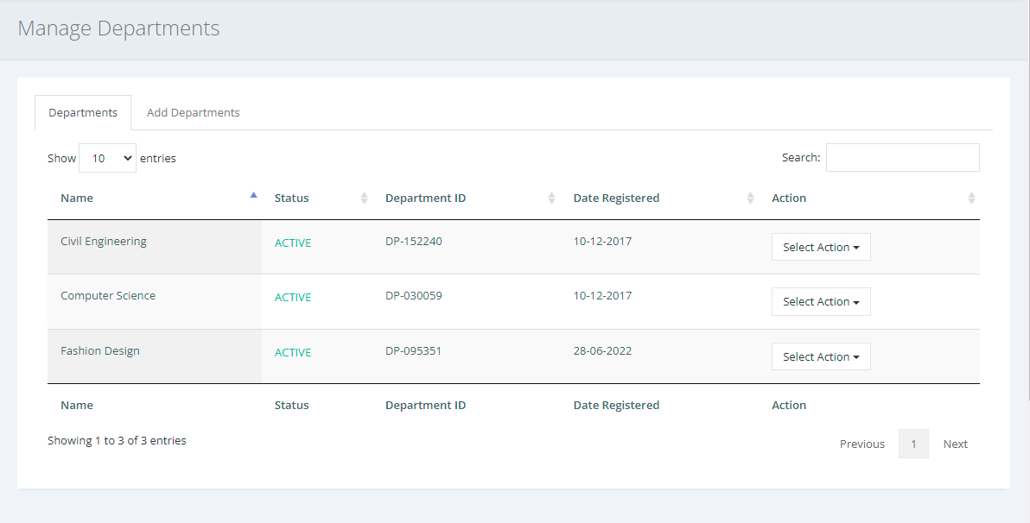

Screenshots 4: Manage Department

The Screenshot 5 illustrates that admin can add new departments if there in not any available department

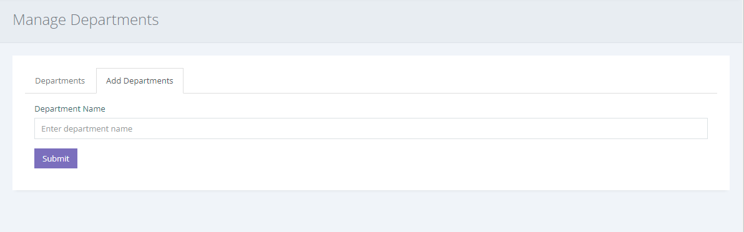

Screenshots 5: Add Department

### Categories

The Screenshot 6 illustrates the list and status of categories within the department which is controlled by admin

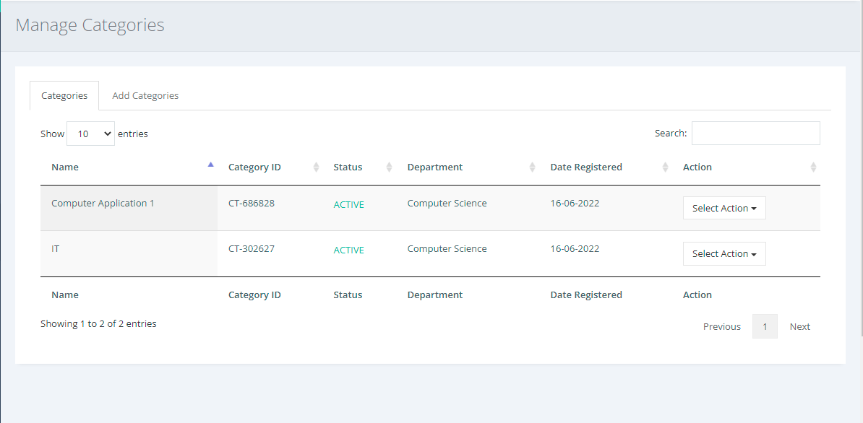

Screenshots 6: Manage Categories

The Screenshot 7 illustrates the addition of new categories related to that department by the admin.

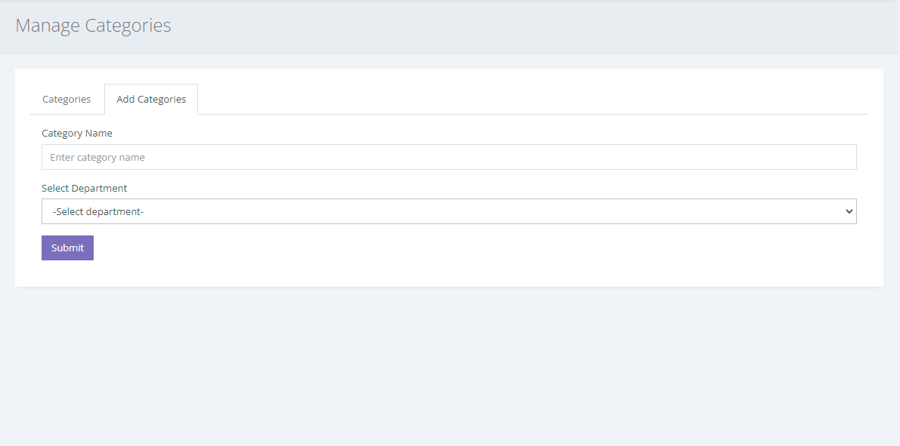

Screenshots 7: Add Categories

### Subjects

The Screenshot 8 illustrates how admin manages subjects within different categories and ensure the status of them

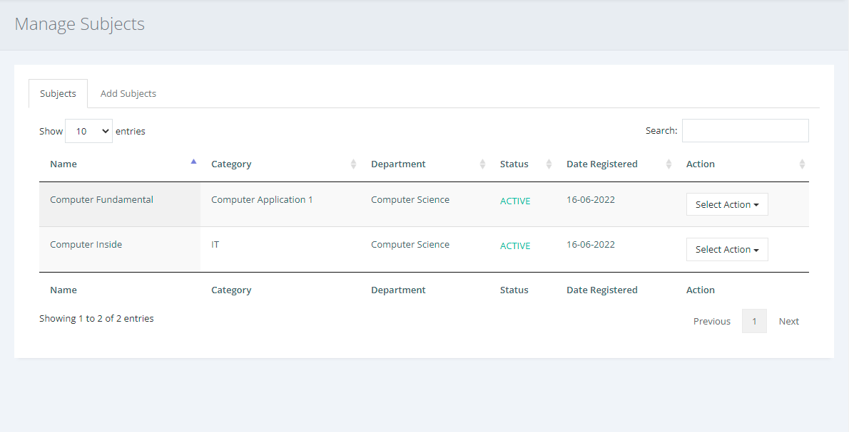

Screenshots 8: Manage Subjects

The Screenshot 9 illustrates that admin can add subjects into specific categories of the department

Screenshots 9: Add Subjects

### Students

The Screenshot 10 illustrates that admin can manage student credentials and can block-list them by dropping them.

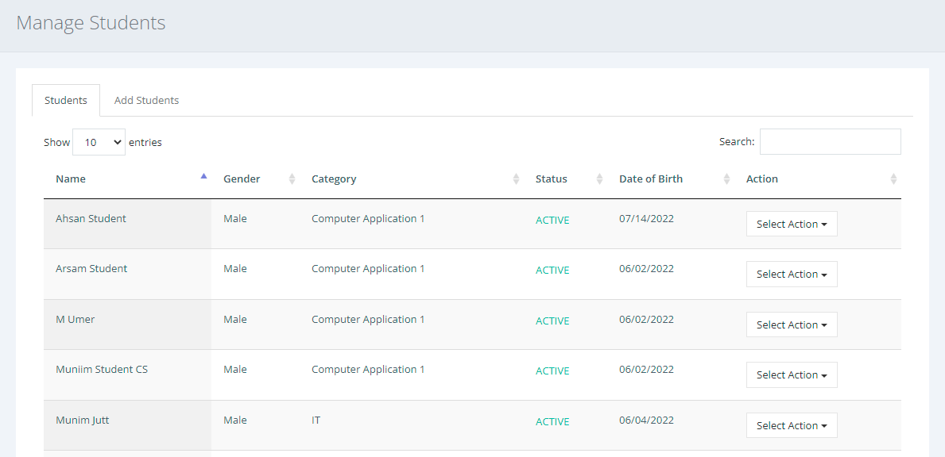

Screenshots 10: Manage Students

The Screenshot 11 illustrates that admin can student credentials in the database for them to login.

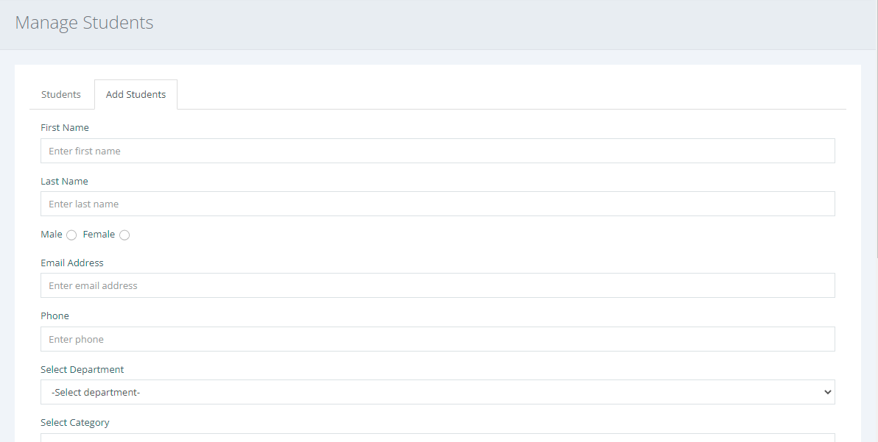

Screenshots 11: Add Students

### Faculty

The Screenshot 12 illustrates that admin have the control of managing teachers as well and to ensure their proper working.

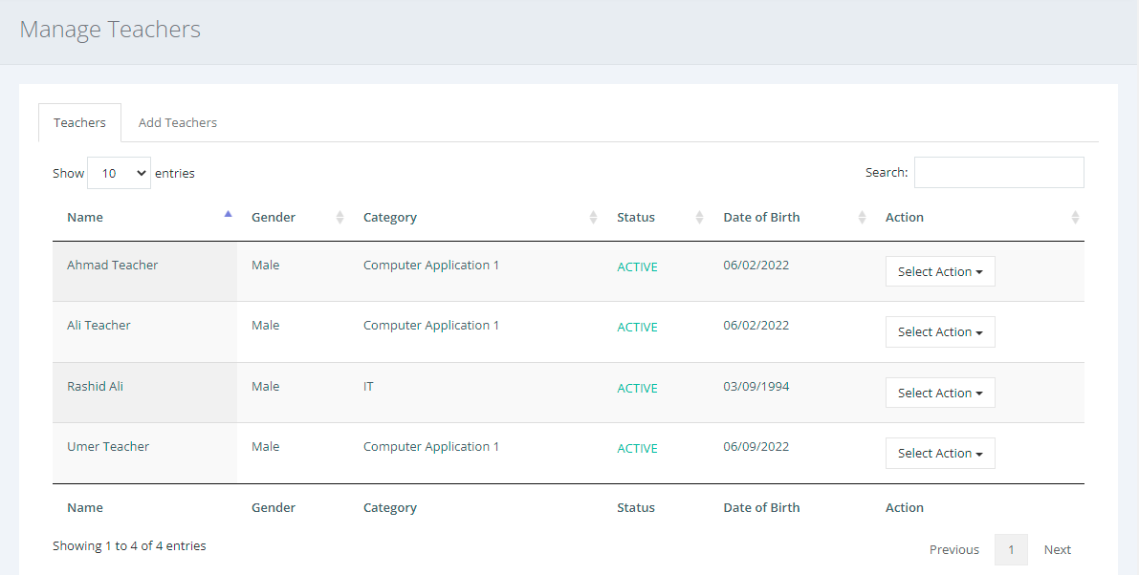

Screenshots 12: Manage Teachers

The Screenshot 13 illustrates that only admin can add teachers who will be teaching a particular subject and more than one teacher can teach the same subject as well .

Screenshots 13: Add Teachers

### Notice

The Screenshot 14 illustrates that only admin can post and manage notices on the board to be read by students and teaches.

Screenshots 14: Manage Notice

The Screenshot 15 illustrates that only admin can write notice.

Screenshots 15: Add Notice

### Export Database

The Screenshot 16 illustrates that admin have the right to make an external copy for backup of the database.

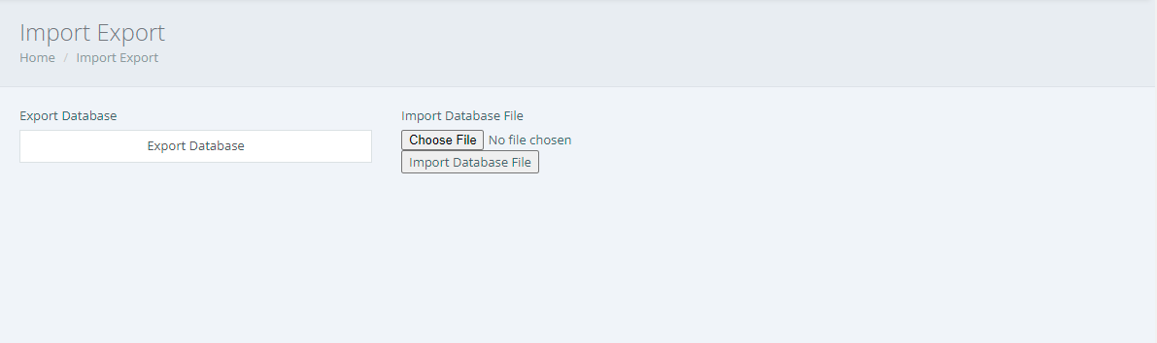

Screenshots 16: Export Database

## Student Panel

### Student Profile

The Screenshot 17 illustrates the student profile with its given credentials.

Screenshots 17: Student Profile

### Dashboard

The Screenshot 18 illustrates the options on dashboard for the ease of students.

Screenshots 18: Dashboard

### Subjects

The Screenshot 19 illustrates the subjects the student undertook.

Screenshots 19: Student Subjects

### Students

The Screenshot 20 illustrates the other students present in one’s class.

Screenshots 20: Students with-in Class

### Examination

The Screenshot 21 illustrates the examinations booth either he wants to practice an assessment or wants to give the exam.

Screenshots 21: Undertaking Exam

The Screenshot 1 illustrates the welcoming screen of the examination on which the student was being with the guidelines of examination.

Screenshots 22: Initiating Exam

The Screenshot 23 illustrates the individual result in a particular exam of the subject.

Screenshots 23: Assessment Result

The Screenshot 24 illustrates the on-going exam (MCQS).

Screenshots 24: On-Going Exam

### Exam Results

The Screenshot 25 illustrates the overall result of an individual in all subjects.

Screenshots 25: Overall Result

## Teacher Panel

### Teacher Profile

The Screenshot 26 illustrates the teacher profile with all its credentials.

Screenshots 26: Teacher Profile

### Dashboard

The Screenshot 27 illustrates the list of options on dashboard with which a teacher can manage and control the activities of the students.

Screenshots 27: Teacher Dashboard

### Subject

The Screenshot 28 illustrates the subjects taught by the teacher in different categories of department.

Screenshots 28: Teaching Subjects

### Send Invitation

The Screenshot 29 illustrates that teacher can send invite to the students for joining the subject.

Screenshots 29: Invitation Pane

### Candidate

The Screenshot 30 illustrates the overall students in the teacher’s class reading a particular subject

Screenshots 30: Overall Students

The Screenshot 31 illustrates that teacher too can add students which directly goes into the database of the system.

Screenshots 31: Add Students

### Examination

The Screenshot 32 illustrates the overall exam that is being conducted.

Screenshots 32: Overall On-Going Exams

### Questions

The Screenshot 33 illustrates that teacher is making an exam of MCQS based. In which he first adds the question followed by the options.

Screenshots 33: Exam Creation (MCQS)

**

Screenshots 34: Exam Creation (S/Q

### Exam Result

The Screenshot 35 illustrates the overall exam result of various subjects.

Screenshots 35: Exams Status

The Screenshot 36 illustrates the result of a particular subject.

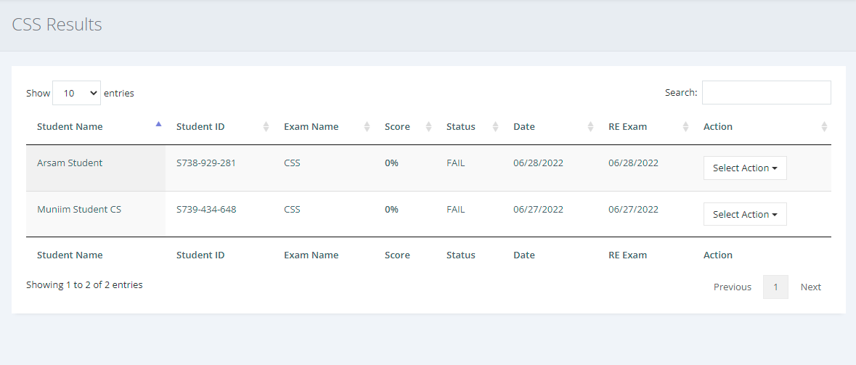

Screenshots 36: Overall Student Result

**Chapter No**

**6**

**References**

# References

## References

*1. Hou, Y. Design and Implementation of Online Examination System based on ASP. NET. in International Conference on Advances in Social Sciences and Sustainable Development (ASSSD 2018). 2018.*

*2. Akinsanmi, O., et al., Development of an e-assessment platform for Nigerian universities. 2010.* ***2****(2): p. 170-175.*

*3. Bobde, S., et al., Web based online examination system. Global Res Develop J Eng, 2017. 2(5): p. 58-61.*

*4. Huszti, A. and A.J.P.M.D. Petho, A secure electronic exam system. 2010.* ***77****(3-4): p. 299-312.*

*5. He, L.J.C.D.i.T.-A.E., A novel web-based educational assessment system with Bloom’s taxonomy. 2006.* ***3****: p. 1861-1865.*

*6. Ayo, C., et al., The prospects of e-examination implementation in Nigeria. 2007.* ***8****(4): p. 125-134.*

*7. Ipaye, B., E-learning in a Nigerian Open University. 2010.*

*8. Rashad, M.Z., et al., An Arabic web-based exam management system. 2010.* ***10****(01): p. 48-55.*

*9. Moodle (web portal). 20 August 2002; Available from:* [*https://sgtechcentre.undp.org/content/sgtechcentre/en/home/featured-work/digital-tools-for-covid-19/tools-for-recovery/Moodle.html?utm_source=EN&utm_medium=GSR&utm_content=US_UNDP_PaidSearch_Brand_English&utm_campaign=CENTRAL&c_src=CENTRAL&c_src2=GSR&gclid=CjwKCAiApfeQBhAUEiwA7K_UH3A7CGBfP7RKjPGXXL5kOXnJQKSrSN1CKT0CEBjtPL21IzgtEM29tBoC0eMQAvD_BwE*](https://sgtechcentre.undp.org/content/sgtechcentre/en/home/featured-work/digital-tools-for-covid-19/tools-for-recovery/Moodle.html?utm_source=EN&utm_medium=GSR&utm_content=US_UNDP_PaidSearch_Brand_English&utm_campaign=CENTRAL&c_src=CENTRAL&c_src2=GSR&gclid=CjwKCAiApfeQBhAUEiwA7K_UH3A7CGBfP7RKjPGXXL5kOXnJQKSrSN1CKT0CEBjtPL21IzgtEM29tBoC0eMQAvD_BwE)*.*

*(This page is left intentionally blank)*